Brain injury Matters annual needs survey 2022

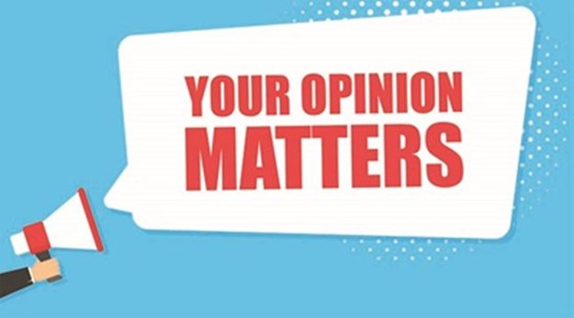

June 2022

SURVEY FINDINGS

Brain Injury Matters (BIM) recently conducted its third annual survey to identify the key issues for people with brain injury. People with brain injury were asked to identify the most important of their support needs, the barriers to participation that they face, and the areas of work which BIM needs to focus on. We also added a question about impact of peer support groups on the lives of people with ABI.

**1. Key Areas Requiring Support**

The two most pressing issues continue to be **Addressing Social Isolation** and **Relationships**. There was a significant drop in those identifying Health as an issue of importance which coincides with the absence of COVID lockdowns in Victoria. The big jump in NDIS as an area requiring support, may reflect concern about the actual or potential tightening of individual NDIS packages.



**2. Main Barriers to Participation**

The top three barriers to participation in the community remained the same in 2022, though there was some shift in the ranking - **Poor attitudes of people in the community** was the top-ranking barrier, followed by **Lack of confidence** and **Lack of knowledge of where to find help**. These are systemic issues and require long-term effort in arrange of spheres to reduce these barriers. These findings reinforce BIM’s current focus on activities and supports, to improve community awareness, build the confidence of people with ABI via training and peer support groups, and providing information on supports.



**3. Focus for BIM**

The strong support for a focus on **Facilitating Peer Support Groups,** Being **a Voice for People** **with a Disability** and **Supporting Self-Advocacy**, gives BIM confidence that the work of the past year in these three areas reflects the priorities of our members. The 24% increase in support of **Facilitating Peer Support Groups** confirms the positive impact of the six BIM peer support groups over the past 12 months. See the results below on Page 4.



**4. The Impact of Peer Support Groups**

The survey found that peer support groups had a positive impact –

86% of the respondents who attended a peer support group reported a positive or very positive impact.

Survey respondents also provided comments. Here is a sample:

* “(the PSG provides) …camaraderie and feeling I am not alone”
* “I feel connected to peers that understand my brain injury. I feel more comfortable speaking with openly and honestly with the support group than I do my closest friends”
* “We all need connection and a community we feel part of. As much as loved ones try to care and understand, nothing compares to meeting and socialising with others that are going through similar life experiences to yourself. It's so good to be understood and accepted”
* “I look forward to the meetings - a highlight of my week.”
* “Others share stories that only people with ABI can truly understand, including me. That is a burden being set free by doing that.”

**5. Best Way to Get Information from BIM**

BIM has continued to provide information and contact through a variety of mechanisms. The BIM Newsletter has been produced monthly for the past year, and it remains an important source of information and connection for many people. BIM provided on-line training and on-line peer support groups over the past 12 months, as reflected in the 2022 survey results. Likewise, the revamped BIM website continues to be an important source of information for people with ABI.



In 2022, 50 people completed the survey, compared with 55 people in 2021, and 52 in 2020.

The BIM Annual Needs Survey gives us valuable information about how to best support and empower people living with brain injury. Thank you to everyone who took the time to complete the survey. If you are interested in seeing the full survey results, please call on 9639 7222 or email office@braininjurymatters.org