Annual Report

2019

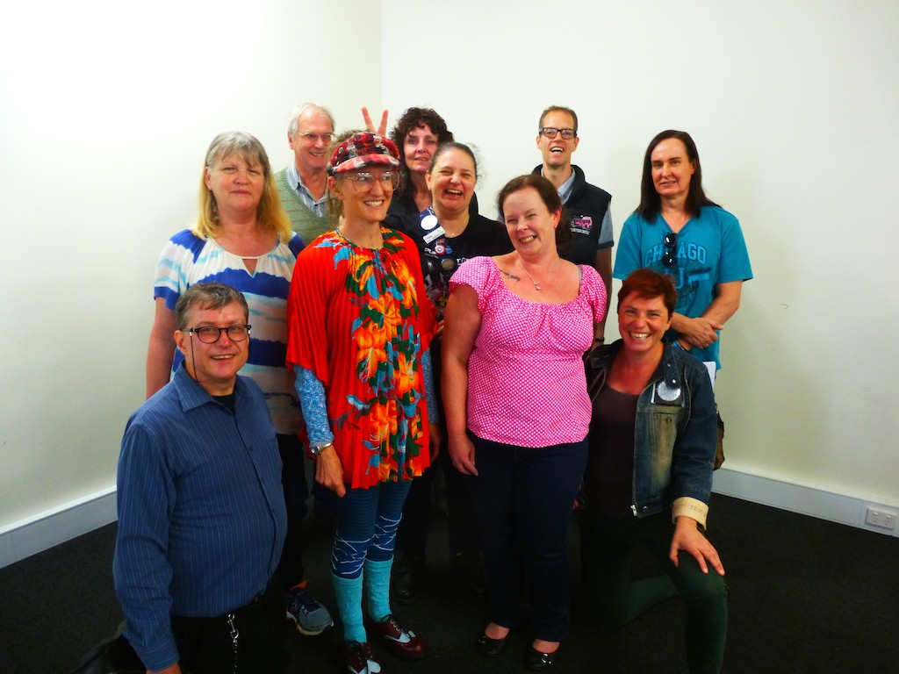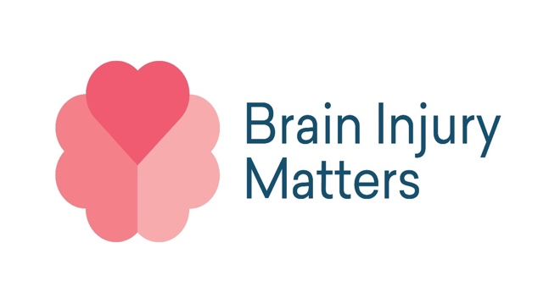

|  |
| --- |
|  |
| 12th November 2019  Agenda for Annual General meeting   |  |  |  | | --- | --- | --- | | 11am | Open Meeting,  Acknowledgment of Country | Neil Cameron | | 11.05am | Apologies,  Confirm minutes of previous AGM | Neil Cameron | | 11.15am | Presidents Report | Manda Laurence , Vice Presidant on behalf of Fran Lee retiring President | | 11.35am | Treasurer’s Report | Roger Astell | | 11.50am | Guest Speaker | Lea Kewish – Foundation Member | | 12.20pm | New Committee Executive confirmed :  *Brent Alford*  *Virginia Giddings*  *Manda Laurence*  *Roger Astell* | Returning Officer  Peter Persson | | 12.25 | Response from Committee | New Secretary Virginia Giddings (Nia)  New President Brent Alford | | 12.35 | Lunch |  | | 1pm | Close meeting |  | |

Presidents Report

There is a lot of change happening in the Victorian disability sector, especially with the rollout of the National Disability Insurance Scheme (NDIS) that focusses on people with disability having more choice and control in their lives. Not everyone is eligible for the NDIS however what it does highlight is the important role advocacy plays in the lives of people with acquired brain injury (ABI). The disability mantra ‘nothing about us without us’ reminds us that we need to have a voice and be at the centre of all decision making processes that impact on our daily lives. It’s a basic human right that we must never take for granted, and we need to keep advocating for.

Brain Injury Matters (BIM) works hard to ensure people feel empowered and more confident about themselves and enacting their rights. This is what self advocacy is all about. BIM also plays a vital role in educating the broader community about the effects of ABI and how things could be improved for people with ABI. So even though our work is very much about individual capacity building, it’s also about what we can achieve together as a group. This can be seen in the many projects we have undertaken in the past twelve months and it couldn’t have been possible without the hard work of so many of the BIM members.

**The Loddon Mallee project**  
In July 2018- June 2019, BIM ran a project in the Loddon Mallee region called ‘Social Media, The Broader Picture’. This was with the support of Bendigo Health and the Department of Health and Human Service (DHHS) Disability Advocacy Sector Capacity Building Fund. This project connected with many ABI peer groups and service providers throughout the Loddon Mallee region, and provided social media training. The experience of ABI can be very isolating and living in a rural area can increase this sense of isolation. This project aimed to support and build capacity of people with ABI to lead independent lives, as well as contribute to communities and support networks in the region.

**The BIM website**

**BIM has been running for over twenty years but as our office is based in the city it is important for us to be able to reach as many people as possible. This is particularly important for people who live in regional and rural areas, and for those who are experiencing isolation due to their ABI. Developing a standalone website was key to sharing information and resources, increasing membership, letting people know about up and coming events, sharing our stories, and connecting people to the ABI Wise app. Special thanks to Kayla, Anne, Larissa, Colin and Melanie who worked tirelessly on the website.**

**The ABI Wise App Project**  
In 2018 and 2019, BIM led a project to build the world’s first App about brain injury, made by people with a brain injury. It was successfully launched in March 2019, and it has been well received across the world. This App is for all mobile devices and contains factual, creative, and entertaining information about how to live well with your brain injury or stroke. We made this App to share our collective wisdom, and hopefully decrease the isolation many people with ABI feel. We hope it will improve the lives of all people living with ABI everywhere.

The ABI Wise App could not have been done without the hard work of many people. This project was inspired by the hard copy kit originally developed for hospitals called ‘The Hitchhikers Guide Through the Brain Maze’, led by former BIM President Peta Ferguson. We used this as a basis to consult with a range of ABI peer support groups and networks across Victoria. Thanks to A Bright Idea in Mornington, Ballarat Stroke Support Group, Compass Clubhouse in Thornbury, Everywoman: Supporting Women with ABI in Bendigo, Geelong ABI Clubhouse, Life’s Appreciation Group in Doveton and United Brains, who all had a say and contributed some great ideas to the App.

Special thanks to the ABI Wise Working Group: Larissa, Brent, Eva, Lisa, Kayla and Melanie who spent many hours reaching out to these groups, developing and designing content, testing the App, and working closely with our various supporting partners. These included BIM members, Self Advocacy Resource Unit, Rachel Edwards from Bandanna Photography, Angus Strachan Productions for videos, Clickify, Leadership Plus and Brain Injury Australia who all helped the App come to life.

The Self Advocacy Resource Unit (SARU)

SARU aims to resource and support self advocacy groups across Victoria and BIM continues to contribute as part of the Management Group. We gain so much from our involvement with SARU, we meet other people with disability, and get to raise our voices and say what services we want and need. Many BIM members have taken part in the Voice At The Table (VATT) training. The VATT project aims to increase the number of people with cognitive disabilities and acquired brain injury to sit on boards, committees and advisory groups. For BIM members this has led to a number of other opportunities, for example, being sought after speakers, expert panellists, facilitators, consumer advocates, video stars and community researchers.

The Victorian ABI Support Network

The consortium group BIM, United Brains and By Accident were successful in receiving an NDIA Information, Linkages and Capacity Building (ILC) one year grant to start the Victorian ABI Support Network. The project has both organisational and individual capacity building activities and commenced in July 2019 and we will report on this further next year.

**We couldn’t do it without you**

**There are so many organisations and people who believe in what we do and partner with us to achieve our goals and appreciate what BIM has to offer. These are some of the partners who we would like to thank.**

* **Australian Federation of Disability Organisation (AFDO)**
* **Action for More Independence & Dignity in Accommodation (AMIDA)**
* **Australia Self Advocacy Project (ASAP)**
* **Brain Injury Australia**
* **Cancer Council**
* **City of Melbourne**
* **Clickify**
* **Department of Health and Human Services**
* **Department of Social Services**
* **Disability Services Commissioner**
* **Leadership Plus**
* **National Disability insurance Agency (NDIA working group)**
* **One Million Stars to End Violence project**
* **Ross House Association**
* **Self Advocacy Resource Unit**
* **Summer Foundation**
* **United Brains**
* **University of Melbourne**
* **Voice at the Table steering committee**
* **Victorian Council of Social Service (VCOSS)**
* **Victorian Self Advocacy Network (VSAN)**

Final note

This is my last year as BIM President and I feel lucky and indeed privileged to have worked alongside so many committed, intelligent and dedicated BIM people. I am grateful that you gave me this opportunity and I have learnt so much from each and every one of you. The best part of being BIM President has been having a chance to bring our beloved group into the limelight. Representation and visibility is so important. The experience has been challenging, inspiring, and amazing. I will continue to be an active contributor to BIM as I have seen how it can make a difference and give a real voice to people with ABI. Long live BIM!

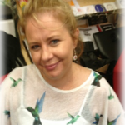

President BIM

Francesca Lee

October 2019

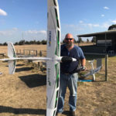Treasurers Report

# **TREASURERS REPORT FOR FINANCIAL YEAR ENDING 30TH JUNE 2019**

As at the 30th JUNE 2019 we had:

➢ $336,890.92 in total funds held.

➢ We currently have in the Bank as at 11th NOVEMBER 2019 $290,331.39

Our Net Equity was at 30th June 2019 was $58,239.62

It has been another year of change with the following notable variances for Brain Injury Matters;

➢ Expenses Increased by $53,713.87 (97.8%) from the previous year.

➢ Income was $61,682.84 or 38.4% more than we received in the financial year ending in June 2018

➢ Remembering also that during the previous year we received $101,740.43 for the Loddon Mallee Project. So, if this previous Project funding is not accounted for, DHHS funding decreased only by 7.04%

➢ Expenses however are broadly in line with expectations for the period being that we both increased staff and activity throughout the year (Loddon Mallee Project & ILC submission). This also included hiring of new staff and increasing our staffing complement (Both Casual / Permanent & Contractual FTE, notwithstanding Volunteers).

➢ Rental Increased under Ross House Rental Agreement due to Room Hire Bookings and number of employees present.

➢ Miscellaneous Income of $3000 was attributed by a payment from SARU for use of BIM Videos on their Website.

➢ Mr Bruce Francis has been instrumental in both setting up our Compliance systems and assisting BIM in securing funding for the ILC Project. This translated to $218,732.45 being secured in this financial year. This amount of $218,732.45 is showing as deferred income on the balance sheet at 30 June 2019 and will show as income in the profit and loss account for the financial period to 30 June 2020. The financial statements will require to be audited for the 30 June 2020 period as income will exceed the audit threshold figure of $250,000.

➢ A Finance Policy has been approved.

THE YEAR AHEAD:

• FRASER BAXTER was employed as our Finance & Administration Officer. Fraser Baxter commenced 20th August 2019 is a qualified ACCA (Association of Chartered Certified Accountants) Accountant with over 12 years accountancy experience working in private practice and industry.

• The financial statements will require to be audited for the 30 June 2020 period as income will exceed the audit threshold figure of $250,000.

• A further round of Funding is being sort via a Grant from NDIS for the benefit the Acquired Brain Injury Community and Groups.

* This project is to be called the “VICTORIAN ABI PEER SUPPORT NETWORK” The amount requested is currently $1,003,046.00 to fund the work required over the next 3 years.

o Year 1 - $213,655

o Year 2 - $378,810

o Year 3 - $410,581

o TOTAL – $1,003,046.00

• A decision is expected as to our proposal from NDIS is expected in December 2019

It is unknown at this time, if this “Grant” is approved if the funds will be directed in totality or over the 3 years in tranches as above.

Based upon the “Funding Success”, future forecasts are unknown. However, based upon current funds and work, BIM has the required capital to continue without this project commencing for funds at hand.

Costs will continue to be well managed. However, considering current staffing levels and requirements for both Insurance requirements (for the new Project) and the need for “Work Cover” to be Victorian Government Compliant, these costs will increase. Bearing in mind we need to ensure all paid staff are protected.

• Costs will continue to be well managed.

• However, considering current staffing levels and requirements for Insurance requirements (for the new Project) and the need for “Work Cover” to be Victorian Government Compliant, these costs will increase. Bearing in mind we need to ensure all paid staff are protected.

• Cost to Income Ratio for 2018 was 34.1 of cost to every Dollar received (1$ of income = 34.1c of costs).Cost to Income Ratio for 2019 was 39.6 of cost to every Dollar received (1$ of income = 39.6c of costs).

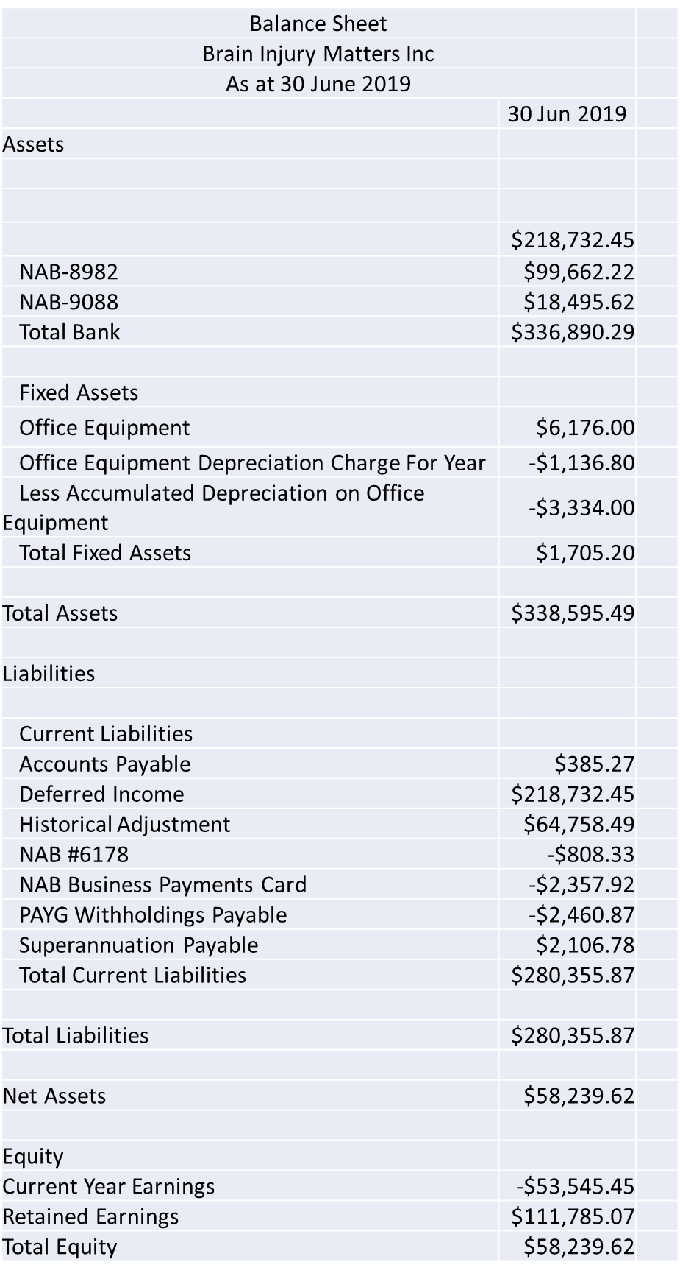



Loddon Mallee Report

In July 2018, Brain Injury Matters with DHHS ILC funding and with the support of Bendigo Health, launched the ‘Social Media, The Broader Picture’ project in Loddon Mallee. BIM employed Kayla Summers and Ann Hutchinson and formed a steering committee of Brent Alford, Kelvin Lim & Francesca Lee to carry out this project.

The project goal was to take the training to the major centres in the area, Mildura, Bendigo etc. and train individuals with ABI how to use various social media platforms in order to stay connected with other people with ABI, access information and support and build their capacity to lead independent and productive lives.

Due to the rural nature of the area, access to support and resources is limited and there are few ABI groups. This along with the vast geographic nature, just under 59000 square kilometers, more than a quarter of Victoria, of the area also makes staying connected difficult for people living with ABI and their supporters.

ABI can, be incredibly isolating, the added challenges created by the area act to compound this. BIM’s work seeks to alleviate this isolation within the ABI community, building communities and support networks within the region and potentially beyond.

During this project, BIM connected with numerous ABI groups and service providers throughout Loddon Mallee region, developed social media training resources for participants and service providers and trained 36 individuals and 21 service providers.

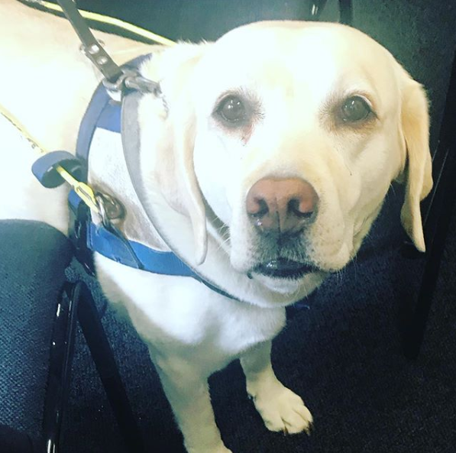

*We would like to thank the outgoing Committee of Management*

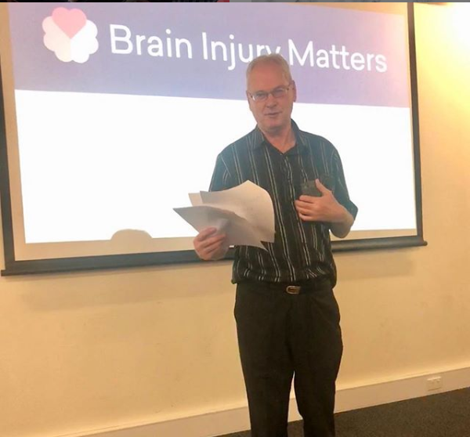

**Brian Injury Matters**

Level 4 Ross House

247 Flinders lane

Melbourne, 3000

office@braininjurymatters.org

Ph 03 96397222