Annual Report
2017-2018

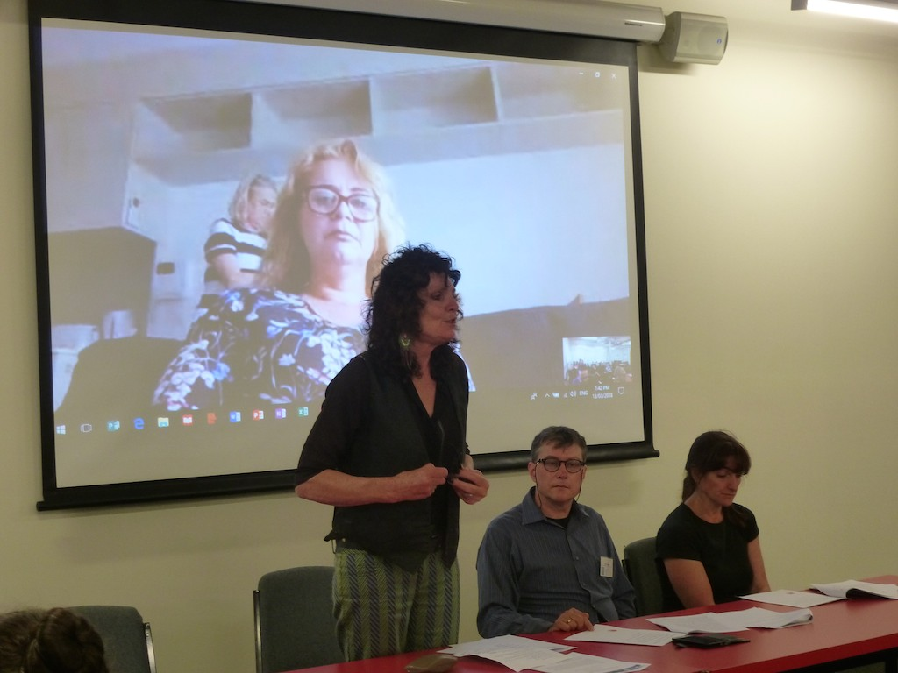

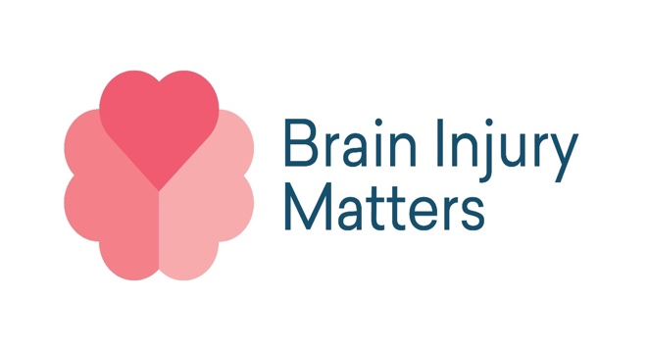

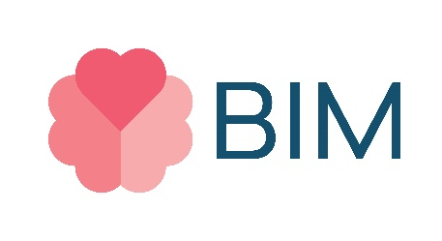
President’s AGM Report
2017 – 2018

During the 2017-8 year the long time President of Brain Injury Matters (BIM) Peta Ferguson retired from the position and was replaced by Francesca Lee. It is fitting that we acknowledge the many years of commitment and work undertaken by Peta to build BIM as an organisation and to highlight the needs of people living with an acquired brain injury.

Peta leaves the organisation stronger and with an increased visibility both to government and the community of the issues facing people living with an acquired brain injury, their needs and the changes that need to take place to increase their inclusion and access to services.

BIM had another big year with some major developments

PROJECTS

Web site redesign:
In July 2017 BIM formed a steering committee of eight members that would meet monthly to work towards relaunching the Brain Injury Matters website funded by DHHS. In October 2017 BIM employed Kayla Summers and Ann Hutchinson to support the project and to work with BIM to create an accessible Website that the work of Brain Injury Matters.

When this project started the website was not accessible and was not creating or encouraging new members for BIM, it also wasn’t currently showcasing all of the wonderful things that BIM is involved in and stands for.

The first task that we took on was to create a logo that represented who BIM is and what is important to them, with the support of the steering committee we employed Milk and Cookies a graphic design company to support us with this, we then went on to employ Clickify to build the structure of our new website.

An important component of the website was to explain what Brain Injury is and who are the members behind Brain Injury Matters. BIM worked with Angus Strachan from Angus Strachan Productions to create 25 videos, a mixture of personal stories and informative videos.

The website was launched on July 25th2018 in Docklands and was celebrated by many BIM members, self advocates, new members and service providers. This website will allow BIM to continue to grow and showcase all of the work they do.

ABI Wise App:
Funding was received from DHHS to produce an ABI Wise app and work was begun on this project. This is very exciting ground breaking project and a fuller report is included later in this annual report.

Loddon Mallee Project:
Funding has been received to undertake a project in the Loddon Mallee region to reduce the social isolation of people living with an acquired brain injury by providing them with social media skills. This project will be implemented in the coming year.

ADVOCACY

Voice at the table and advocating for people living with an acquired brain injury:
BIM members co-facilitated the Voice at the Table training provided to people with ABI, as well the training provided to organisations and government departments. A number of BIM members also undertook Voice at the Table training and have been representing the views of BIM and people with an acquired brain injury (ABI) to boards and committees of organisations since then including the Cancer Council, TAC, Disability Services Commissioner, Melbourne University and VCOSS.

Representing people living with an acquired brain injury
BIM members have been representing people living with an acquired brain injury on organisations in the disability sector including SARU, Victorian Self Advocacy Network and the NDIS working group.

Distribution of the Hitchhikers Guide to the Brain Maze
A team distributed the Hitchhiker’s Guide to the Brain Maze to hospitals throughout Melbourne

Dangerous Deeds
BIM took part in the Dangerous Deeds project as it travelled the state. This included the screening of our film, participation in the ‘White Night’ in Warrnambool and presented two ABI culture workshops in Moe and Warrnambool – this was a joint presentation with United Brains

Disability Pride Mural
BIM members participated in Australia’s first Disability Pride Mural in Footscray in November 2027. This project was initiated and bought to fruition by BIM member Larissa MacFarlane and is a creative way of bringing increased visibility to people living with an acquired brain injury

PARTNERS
BIM continued its close working relationship and partnership with United Brains (UB). BIM continues to act as the legal auspice for UB and the two organisations continue to look for ways to work together for the betterment of the sector and people living with an acquired brain injury. BIM continues to work closely with other organisations including United Brains, SARU, Clickify, AMIDA, Bendigo Health, Disability Commissioners Office, DHHS, New Wave, All Abilities Advocacy SW Vic, stART , Wesabi, Melbourne City Council, VCOSS and The Transport Ombudsman.

OTHER ACHIEVEMENTS
BIM undertook an office revamp designed to both improve the working space and to create a better space for members use that encourages their increased engagement with BIM and increased social engagement and self advocacy.

We look forward to another big year in 2018-9

Francesca Lee
President BIM

ABI Wise App
The ABI Wise App Project began life in January 2018, as part of the SARU Partnerships project, funded by DHHS. This is a very exciting initiative that will provide access to information, stories and resources from a person’s phone. The app will increase access to information and services, reduce social isolation and marginalisation and help share peer experiences of living with an acquired brain injury and successfully negotiating the changes that have taken place in their lives.

The potential for people to offer and to share their experiences is very powerful and offers people struggling with the changes in their lives to use the experiences and wisdom of others who share their experiences. This peer support has powerful benefits for all.

In March, Melanie Keely was employed by SARU to Co-ordinate the project. BIM attended planning meetings with SARU, alongside Positive Powerful Parents (PPP) and Diversity and Disability (DnD).

In early April 2018, SARU/BIM employed Kayla Summers as a BIM project worker (1 day/week). We held interviews in April to find a BIM ABI peer project worker and employed Larissa MacFarlane (1 day/week) who started in May. We then set up a working group, which included Larissa, Brent Alford, Eva Sifis and Lisa Brumtis as the active members.

We researched ABI organisations with a view to partnering. We also studied the Hitchhikers Guide to the Brain Maze Kit and its potential for inclusion and adaptation in an App. We created a project plan to make an App about ABI. We also attended monthly Partnership Project meetings with PPP and DnD.

When this project is completed it will be a first in Australia and as far as we know a global first and takes our self advocacy to a whole new level.

Larissa MacFarlane
Peer Project Worker

TREASURERS REPORT

FINANCIAL YEAR ENDING 30TH JUNE 2018

As an introduction, my name is Roger Astell. I was asked to help Brain Injury Matters after completing a course with SARU called Voice at the Table.

I have a Master of Business Administration Degree (M.B.A. – Deakin University) and my background until 9 years ago was with the ANZ Bank (Snr Manager Financial Planning Operations) followed by Industry Super (National Manager Operations) and Australian Super where my last position was as the Executive Coach.

Overview of the organisations Finances
The 2017-8 financial year has been a successful one from a finance perspective with BIM showing a surplus of $105,732 at the end of the financial year. However, it needs to be pointed out that most of those funds are committed to implement the Loddon Mallee project in 2018-9 with these funds having been received late in the financial year.

Key financial outcomes
- Account Balances as at the 30th June 2018 were $186,722.28 Credit

- The income for the year included:
  - AMIDA consultancy $6,436.85,
  - DHS Funding increased by 232.5% or by $114,245.68 which included additional funding of $101,740.43 for the Loddon-Mallee Project.

- Expenses included:
  - Staff costs for the BIM support worker
  - A number of outstanding payments of invoices in some instances were not completed or received within this Financial Year. These however do not change in any substantive way the organisations sustainable financial situation
  - Fees for Bookkeeping, Business Listing and or Conference Workshops not charged to accounts during this 2017/18 Financial year.
  - Some abnormal expenses were incurred. The Website was one of these which was unplanned and required technical repair and stabilisation.

- Other financial indicators
- Cost to Income Ratio for 2017 was 96.9c of cost to every Dollar received (1$ of income = 96.9c of costs).
- Cost to Income Ratio for 2018 was 34.1 of cost to every Dollar received (1$ of income = 34.1c of costs).

Future Developments

- The Loddon-Mallee Project expenses will mainly fall in the next financial year although the income for this project was received in this financial year.
- A Compliance Officer is currently being sorted, to further assist in both staff training and to improve our policies, practices and reporting
- A Finance Policy is under development and will be put to both the BIM Executive and Committee of Management for formal review and sign off.
- Continuing review on expenditures will occur to ensure our cost to income ratio is as efficient for our membership as possible over the forthcoming year.

Profit & Loss Statement from 1st July 2017 to 30th June 2018

Profit and Loss
Brain Injury Matters
1 July 2017 to 30 June 2018
 | As at the 30th June 2018 | $ Movement from 30th June 2017 | %
Income
SARU Grant | $0.00 | -$6,162.13 | -100%
AMIDA Consultancy | $6,436.85 | $6,436.85 | 100%
Reimbursements / Bank Deposits | $0.00 | -$19.00 | -100%
DHS General Funding | $154,209.54 | $107,827.83 | 232.5%
Total Income | $160,646.39 | $114,245.68 | 246.2%
Gross Income | $160,646.39 | $61,682.84 | 62.3%
Less Operating Expenses
Advertising | $2,399.00 | -$2,399.00 | -100%
Bookkeeping Fees | $0.00 | $3,564.00 | 100%
Business Listing | $0.00 | $7,538.40 | 100%
Conferences & Workshops | $0.00 | $2,120.55 | 100%
Consultants | $395.86 | -$7.86 | -2.0%
Equipment Purchase | $0.00 | $513.00 | 100.0%
General Expenses | $257.50 | -$257.50 | -100%
Honorariums | $0.00 | $1,131.29 | 100.0%
Meeting Attendances | $1,480.00 | -$1,480.00 | -100%
Office Expenses | $306.99 | -$306.99 | -100%
Office Supplies | $167.95 | -$49.02 | -41.2%
Other | $0.00 | $971.81 | 100%
Postage | $0.00 | $4.35 | 100%
Photocopying | $0.00 | $255.00 | 100%
Rent | $9,449.21 | $535.09 | 5.4%
Repairs and Maintenance | $1,010.10 | -$1,010.10 | -100%
Subscriptions | $999.00 | -$999.00 | -100%
Superannuation | $2,091.84 | -$2,091.84 | -100%
Telephone & Internet | $2,367.89 | $883.35 | 27.2%
Travel/Meals/Accommodation | $2,090.66 | -$2,090.66 | -100%
Volunteer Expenses & Travel | $0.00 | $1,018.82 | 100%
Wages and Salaries | $22,883.06 | -$8,744.06 | -61.8%
Website | $9,015.00 | -$9,015.00 | -100%
Total Operating Expenses | $54,914.06 | -$9,915.37 | -22.0%
Net Surplus | $105,732.33
Committee of Management 2017-8
President:
Peta Ferguson/Francesca Lee
Secretary:
Troy Huggins/Brent Alford
Treasurer:
Lisa Brumtis/Troy Huggins. Report completed by current Treasurer Roger Astell
Vice President:
Francesca Lee/Larissa MacFarlane
Members: Helen Caligiuiri
Eva Sifis
Jeff Howe
Barbara Smith

Staff
BIM Support worker: Jan Coles
Website project/ ABI Wise Project: Kayla Summers
Website project: Ann Hutchinson
ABI Wise Project: Larissa MacFarlane
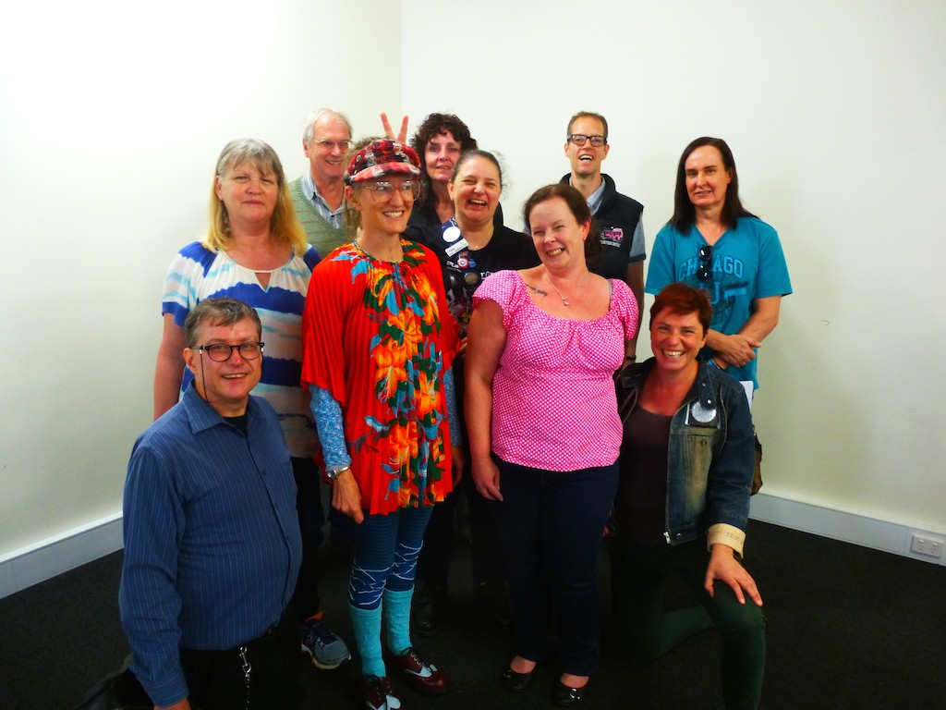
Brian Injury Matters
Level 4 Ross House
247 Flinders lane
Melbourne, 3000
office@braininjurymatters.org
Ph 03 96397222

